website data

**1-home**

**www.Poulex-group.com**

eng arab

**home about us products projects gallery contact us**

**brief story news**

**fancom logo percoli logo roxell logo poulex intl logo**

**2-about us**

2.1-history

2.2-vision

2.3 new poulex

2.4 factory

**3- products and services**

3.1 poultry equipments

3.2 Prefabricated steel sturcture

3.3-services

3.1.1- feeding and drinking systems and solutions

3.1.2- ventilation and heating systems

3.1.3- House Control

3.1.4 -Lighting Systems

3.2.1 Prefabricated poultry houses

3.2.2- prefabricated warehouses

3.2.3- prefabricated factories and showrooms

3.2.4- prefabricated rest houses .

**4- projects**

4.1 inside Egypt

4.2 outside Egypt

5-gallary

6- Contact Us

**about us**

**history**

**It was 1984 when Assem Halim founded his company "Poulex", located in Giza, Egypt.**

**With a specific vision which is to introduce modern and scientific poultry solutions and concepts in a time when these methods weren’t familiar to the local market**

**Since then Poulex has been one of the leading companies in Egypt and the middle east in the supply of turn-key projects for poultry and livestock, providing the latest technologies and concepts.**

**vision**

**Our vision is to maximize our client’s satisfaction by granting the best possible results not only by granting the best quality products but also to provide the support needed before and after production with full time customer service.**

**New poulex:**

**New generation of Poulex was established in 2015 under the name of New Poulex with different varieties of economical solutions and modern systems to reach all customers needs.**

**New Poulex is the exclusive agent of the leaders of poultry equipment companies worldwide such as:**

**Roxell (belgium): for drinking and feeding solutions**

**pericoli termotechnica (italy): for ventilation solutions**

**fancom(netherlands): for house control solutions**

**hato(netherlands): for lighting solutions**

**factory**

**Poulex International has been projecting and manufacturing pre fabricated poultry sheds of any size and typology for the last 15 years.**

**Also providing prefabricated steel buildings,**

**rest houses and warehouses.**

**Our poultry houses and livestock sheds grant the highest productive level, by ensuring the best environment to the animals, in any climatic condition.**

**Products**

**3.1 POULTRY EQUIPENT**

**A- Feeding and Drinking solution**



* ROXELL, located in Maldegem, Belgium, is the worldwide leader in automatic feeding and drinking systems for the poultry industry.

**A.1.Feeding System :**

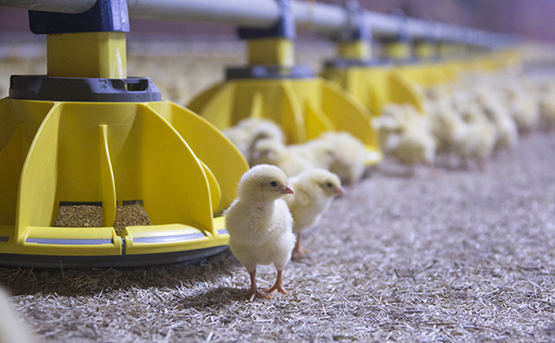 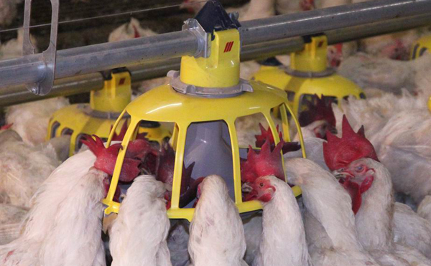  [**Broilers**](http://www.roxell.com/en/systems/Poultryfeeding/Broilers/index.html)[**Broiler breeders**](http://www.roxell.com/en/systems/Poultryfeeding/BroilerBreeders/index.html)

1. [CoMeo](http://www.roxell.com/en/systems/Poultryfeeding/Broilers/CoMeo/index.html) 1. [Boozzter](http://www.roxell.com/en/systems/Poultryfeeding/BroilerBreeders/Boozzter/index.html)
2. [HaiKoo](http://www.roxell.com/en/systems/Poultryfeeding/Broilers/HaiKoo/index.html) 2. [BRIDOMAT](http://www.roxell.com/en/systems/Poultryfeeding/BroilerBreeders/BRIDOMAT/index.html)
3. [MINIMAX *line*](http://www.roxell.com/en/systems/Poultryfeeding/Broilers/MINIMAXline/index.html)  3. [KiXoo](http://www.roxell.com/en/systems/Poultryfeeding/BroilerBreeders/KiXoo/index.html)

4. [Vitoo](http://www.roxell.com/en/systems/Poultryfeeding/BroilerBreeders/Vitoo/index.html)

[**Commercial layers**](http://www.roxell.com/en/systems/Poultryfeeding/CommercialLayers/index.html)

1. [BRIDOlay](http://www.roxell.com/en/systems/Poultryfeeding/CommercialLayers/BridoLay/index.html)
2. [LaïCa](http://www.roxell.com/en/systems/Poultryfeeding/CommercialLayers/LaiCa/index.html)
3. [Poolaï](http://www.roxell.com/en/systems/Poultryfeeding/CommercialLayers/Poolai/index.html)

**A.2.Drinking System:**

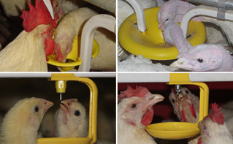

**For all poultry**

1. [SPARKcup](http://www.roxell.com/en/systems/Poultrydrinking/Sparkcup/index.html)
2. [Swii'Flo](http://www.roxell.com/en/systems/Poultrydrinking/Swiiflo/index.html)

# Poultry Nesting systems

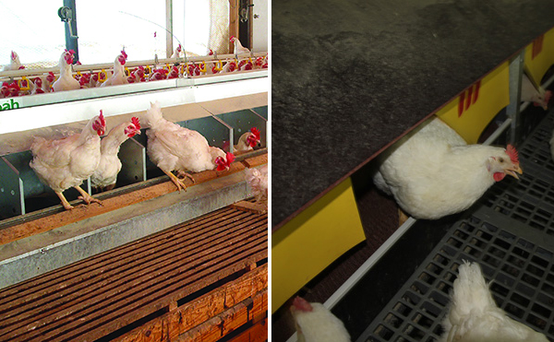

1. [Koozii](http://www.roxell.com/en/systems/Poultrynests/Koozii/index.html)
2. [Shenandoah](http://www.roxell.com/en/systems/Poultrynests/Shenandoah/index.html)

Solutions

**1-For Broiler**

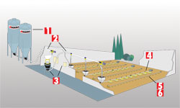

## Floor housing Cages

1. [STORAGEline](http://www.roxell.com/en/solutions/Broilers/Storage/index.html) 1. STORAGEline
2. [Flex-Auger](http://www.roxell.com/en/solutions/Broilers/Flex-Auger/index.html) 2.Flex-Auger
3. [CONTROLline](http://www.roxell.com/en/solutions/Broilers/CONTROLline/index.html) 3.CONTROLline
4. [CoMeo](http://www.roxell.com/en/solutions/Broilers/CoMeo/index.html) -  [HaiKoo](http://www.roxell.com/en/solutions/Broilers/HaiKoo/index.html) - [MINIMAX](http://www.roxell.com/en/solutions/Broilers/MINIMAXline/index.html) 4.[CoMeo](http://www.roxell.com/en/solutions/Broilers/CoMeo/index.html) -  [HaiKoo](http://www.roxell.com/en/solutions/Broilers/HaiKoo/index.html)
5. [SPARKcup](http://www.roxell.com/en/solutions/Broilers/Sparkcup/index.html) 5.Swii'Flo
6. [Swii'Flo](http://www.roxell.com/en/solutions/Broilers/Swiiflo/index.html)

**2-For Broiler Breeder**

## [Rearing](http://www.roxell.com/en/solutions/BroilerBreeders/Rearing/index.html)

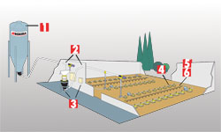

1. [STORAGEline](http://www.roxell.com/en/solutions/BroilerBreeders/Rearing/Storage/index.html)
2. [FLEX-AUGER](http://www.roxell.com/en/solutions/BroilerBreeders/Rearing/Flex-Auger/index.html)
3. [CONTROLline](http://www.roxell.com/en/solutions/BroilerBreeders/Rearing/CONTROLline/index.html)
4. [Vitoo](http://www.roxell.com/en/solutions/BroilerBreeders/Rearing/Vitoo/index.html)
5. [SPARKcup](http://www.roxell.com/en/solutions/BroilerBreeders/Rearing/Sparkcup/index.html)
6. [Swii'Flo](http://www.roxell.com/en/solutions/BroilerBreeders/Rearing/Swiiflo/index.html)

## [Production](http://www.roxell.com/en/solutions/BroilerBreeders/Production/index.html)

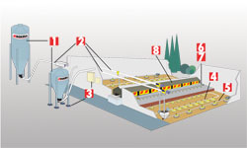

1. [STORAGEline](http://www.roxell.com/en/solutions/BroilerBreeders/Production/Storage/)
2. [FLEX-AUGER](http://www.roxell.com/en/solutions/BroilerBreeders/Production/Flex-Auger/index.html)
3. [CONTROLline](http://www.roxell.com/en/solutions/BroilerBreeders/Production/CONTROLline/index.html)
4. [KiXoo](http://www.roxell.com/en/solutions/BroilerBreeders/Production/KiXoo/index.html) - [BRIDOMAT](http://www.roxell.com/en/solutions/BroilerBreeders/Production/BRIDOMAT/index.html)
5. [Boozzter](http://www.roxell.com/en/solutions/BroilerBreeders/Production/Boozzter/index.html)
6. [SPARKcup](http://www.roxell.com/en/solutions/BroilerBreeders/Production/Sparkcup/index.html)
7. [Swii'Flo](http://www.roxell.com/en/solutions/BroilerBreeders/Production/Swiiflo/index.html)
8. [Koozii](http://www.roxell.com/en/solutions/BroilerBreeders/Production/Poultrynests/index.html)

## [Day old to death](http://www.roxell.com/en/solutions/BroilerBreeders/Day-old-death/index.html)



1. [STORAGEline](http://www.roxell.com/en/solutions/BroilerBreeders/Day-old-death/Storage/index.html)
2. [FLEX-AUGER](http://www.roxell.com/en/solutions/BroilerBreeders/Day-old-death/Flex-Auger/index.html)
3. [CONTROLline](http://www.roxell.com/en/solutions/BroilerBreeders/Day-old-death/CONTROLline/index.html)
4. [KiXoo](http://www.roxell.com/en/solutions/BroilerBreeders/Day-old-death/KiXoo/index.html)
5. [Boozzter](http://www.roxell.com/en/solutions/BroilerBreeders/Day-old-death/Boozzter/index.html)
6. [SPARKcup](http://www.roxell.com/en/solutions/BroilerBreeders/Day-old-death/Sparkcup/index.html)
7. [Swii'Flo](http://www.roxell.com/en/solutions/BroilerBreeders/Day-old-death/Swiiflo/index.html)
8. [Koozi](http://www.roxell.com/en/solutions/BroilerBreeders/Day-old-death/Poultrynests/index.html)

**3-For Commercial Layers**

## [Rearing](http://www.roxell.com/en/solutions/Layers/Rearing/index.html)

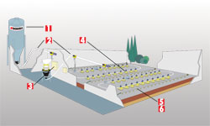

1. [STORAGEline](http://www.roxell.com/en/solutions/Layers/Rearing/Storage/index.html)
2. [FLEX-AUGER](http://www.roxell.com/en/solutions/Layers/Rearing/Flex-Auger/index.html)
3. [CONTROLline](http://www.roxell.com/en/solutions/Layers/Rearing/CONTROLline/index.html)
4. [Poolaï](http://www.roxell.com/en/solutions/Layers/Rearing/Poolai/index.html)
5. [SPARKcup](http://www.roxell.com/en/solutions/Layers/Rearing/Sparkcup/index.html)
6. [Swii'Flo](http://www.roxell.com/en/solutions/Layers/Rearing/Swiiflo/index.html)

## [Production](http://www.roxell.com/en/solutions/Layers/Production/index.html)

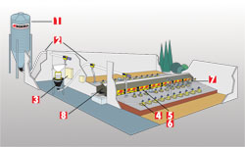

1. [STORAGEline](http://www.roxell.com/en/solutions/Layers/Production/Storage/index.html)
2. [FLEX-AUGER](http://www.roxell.com/en/solutions/Layers/Production/Flex-Auger/index.html)
3. [CONTROLline](http://www.roxell.com/en/solutions/Layers/Production/CONTROLline/index.html)
4. [LaïCa](http://www.roxell.com/en/solutions/Layers/Production/LaiCa/index.html) - [BRIDOlay](http://www.roxell.com/en/solutions/Layers/Production/BridoLay/index.html)
5. [SPARKcup](http://www.roxell.com/en/solutions/Layers/Production/Sparkcup/index.html)
6. [Swii'Flo](http://www.roxell.com/en/solutions/Layers/Production/Swiiflo/index.html)
7. [Le Roozzt](http://www.roxell.com/en/solutions/Layers/Production/Poultryperching/index.html)
8. [Koozii](http://www.roxell.com/en/solutions/Layers/Production/Poultrynests/index.html)

## [Day old to death](http://www.roxell.com/en/solutions/Layers/Day-old-death/index.html)



1. [STORAGEline](http://www.roxell.com/en/solutions/Layers/Day-old-death/Storage/index.html)
2. [FLEX-AUGER](http://www.roxell.com/en/solutions/Layers/Day-old-death/Flex-Auger/index.html)
3. [CONTROLline](http://www.roxell.com/en/solutions/Layers/Day-old-death/CONTROLline/index.html)
4. [Poolaï](http://www.roxell.com/en/solutions/Layers/Day-old-death/Poolai/index.html)
5. [SPARKcup](http://www.roxell.com/en/solutions/Layers/Day-old-death/Sparkcup/index.html)
6. [Swii'Flo](http://www.roxell.com/en/solutions/Layers/Day-old-death/Swiiflo/index.html)
7. [Le Roozzt](http://www.roxell.com/en/solutions/Layers/Day-old-death/Poultryperching/index.html)
8. [Koozii](http://www.roxell.com/en/solutions/Layers/Day-old-death/Poultrynests/index.html)

**B-Ventilation System:**



Pericoli Group today is a growing reality and a global leader in ventilation. Offering products characterized by the quality of an Italian original design. Using the most advanced R&D technologies, proposing efficient environment solutions, able to increase production minimizing the operating costs.

**B.1 Ventilation**

Pericoli offers a full range of exhaust and circulator fans capable to meet the customers’ needs by ensuring excellent and certified performances  for livestock buildings, greenhouses and industrial applications.

### Exhaust Fans

* 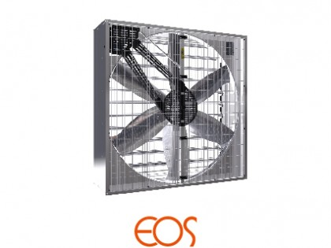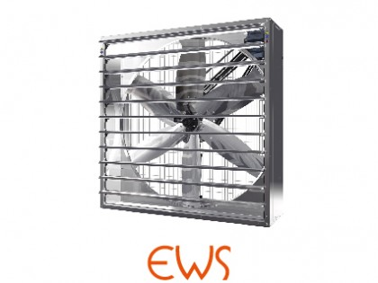
* 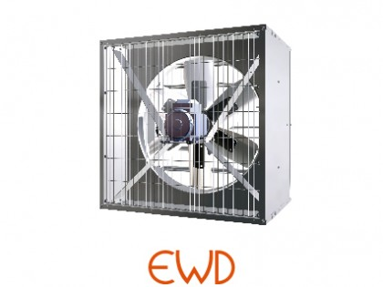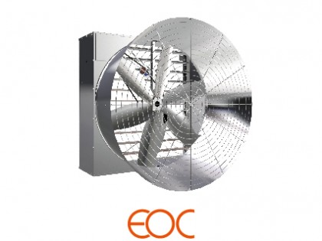

### Circulation Fans

* 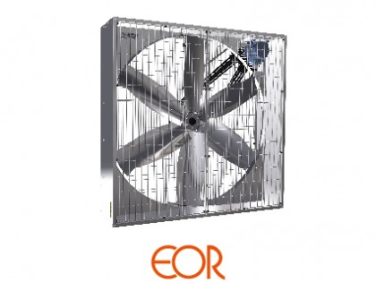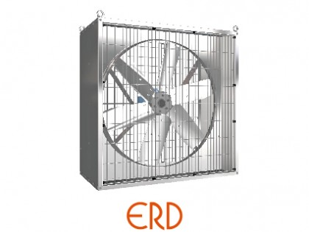
* 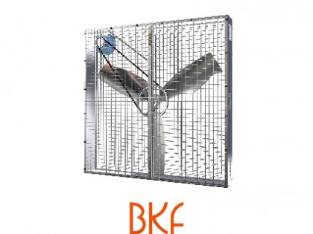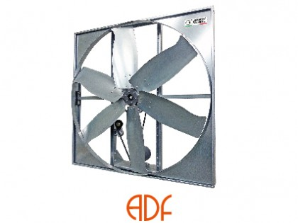
* 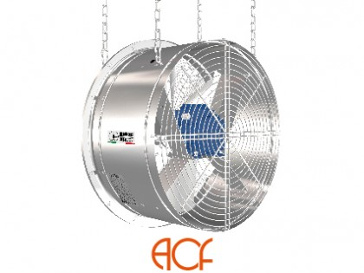

**B.2 Heating**

a wide range of heaters in many different shapes and sizes, whose main features look at the efficiency, versatility and thermal efficiency.

* 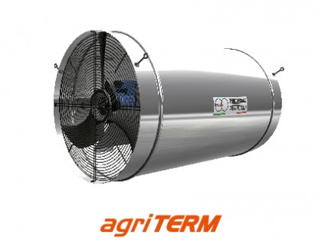 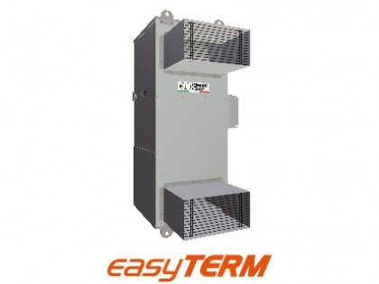
* 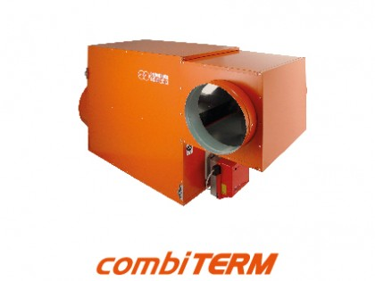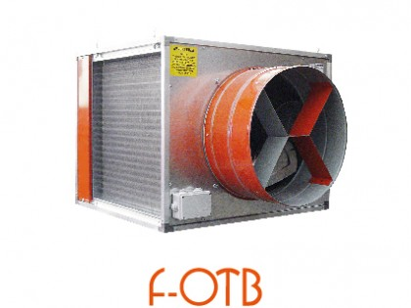

**B.3 Cooling**

Based on the simple physical principle of adiabatic cooling, Pericoli's cooling line provides the perfect combination of usability, reliability and low running costs, thus becoming the greenest solution ever to solve the problem of excessive heat in large environments.

* 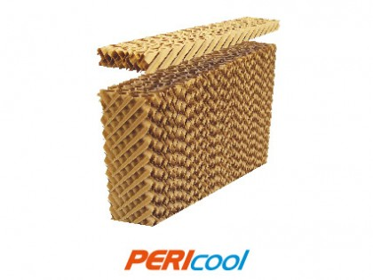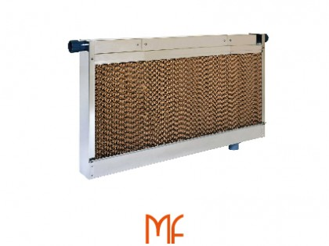
* 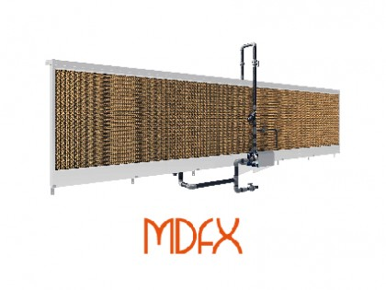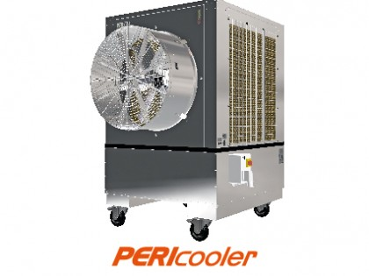

**C-Control System**



Fancom is the global leader in the development of IT and automation systems for the intensive livestock husbandry sector.

Fancom develops total house management systems, consisting of climate control, feeding automation, biometrics and data management. Naturally, the parts that make up the systems differ per sector.  
Fancom has different types of control for different purposes.

**C.1-Climate control**

Fancom has different types of climate control systems that helps controlling mechanical ventilation, Fan position control, Minimum ventilation precision control , Heating control , Humidity control and Cooling control.

FCJC , F37 , F38 , Lumina 37 and Lumina 38 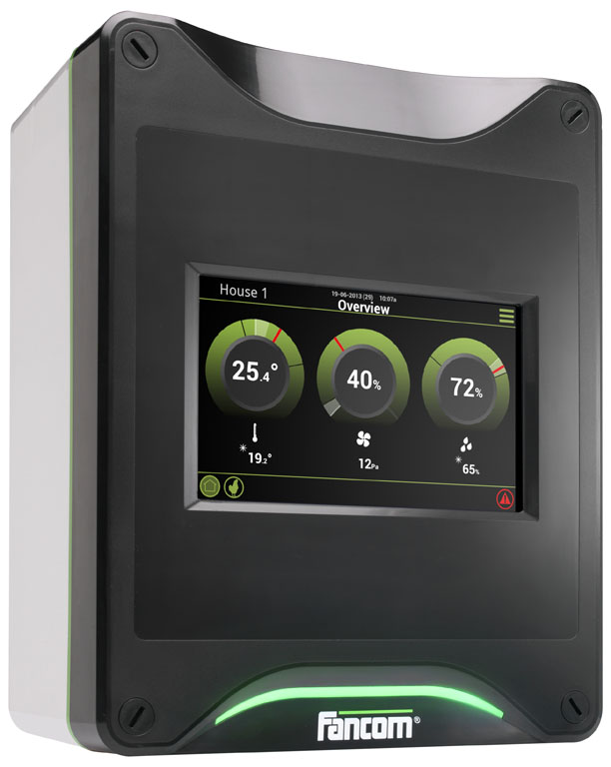 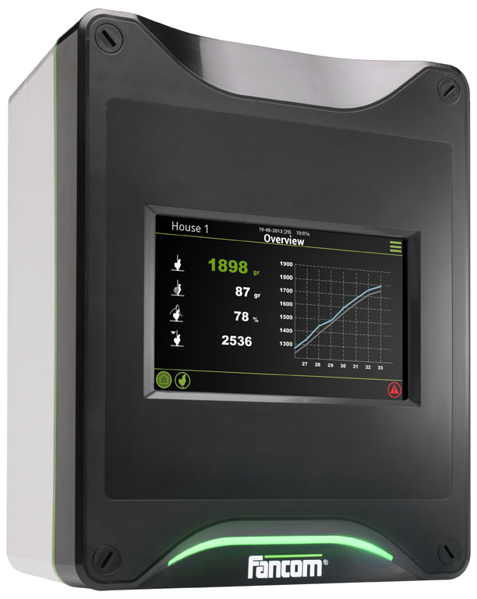

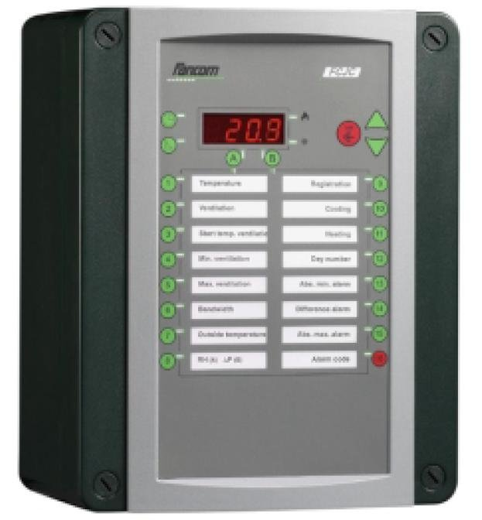

Weighing systems  
 bird weighing : F47 , 747

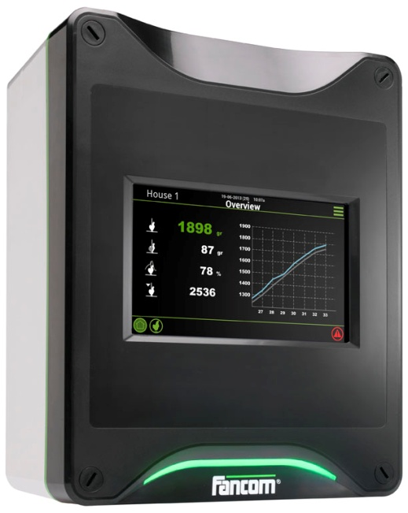 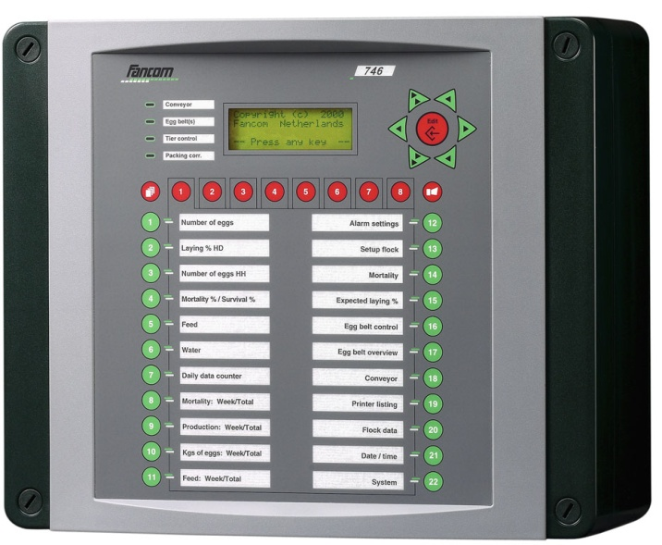  
 silo Weighing : FWSC

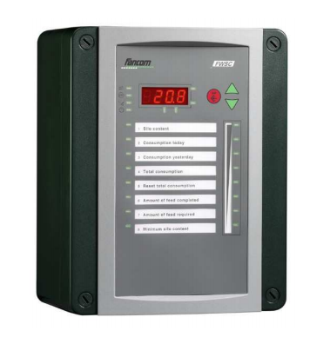

# FarmManager

The automated climate, feed and biometric processes form a valuable source of information in your house. They provide information about the environment the animals are living in, their individual behaviour and the feed and water consumption.The unifying link with iFarming is through our management software. This software automatically gathers, processes and presents the information in tables and graphs. The result is a wealth of management data that allows you to steer towards improvements based on facts and figures. Registration is learning!

## F-Central FarmManager™

## [FarmManager](http://www.fancom.com/image/ffaaac99e573cdf9f1b14aef1bbd82ff78d77225/default.jpg)

F-central

FarmManager™ software links you to your houses 24 hours a day. You can check on the situation in the house, no matter where you are in the world. Any alarms can be sent to your PC, tablet computer or smartphone. And, if necessary, you can adjust the settings in the control computers remotely to improve the processes in the house. The result is a perfect overview of your company and insight into production costs and the technical results.

## FarmManager For Broilers™

FarmManager for Broilers™ is an additional component in the F-Central FarmManager™ range. It registers, and clearly shows, the most important performance indicators in the house, such as growth, feed and water consumption and activity. FarmManager for Broilers™ automatically combines that latest data from the climate, feed and weighing computers in the house, so that you can monitor production daily and compare and benchmark the results. You can compare the latest information from your houses with the standard index figures, with the farm average, the group average, or with data from previous production cycles.

For more info send an email to info@poulex-group.com

**D-lighting Systems**



HATO BV is one of the world’s leading manufacturers of agricultural lighting solutions.

the ideal solutions for main lighting

Lighting plays a major factor in the welfare of poultry. The Corax lamp gives perfect light distribution. Thanks to its fixation system it is possible to install the CORAX on ceiling, wall or with steel suspension wire.

Specifications:

* High energy efficiency
* Long life 60,000 hour at high temperature
* IP67 , water resistant , easy to clean with water pressure
* No need for qualified electrician (48VDC)
* Different colors available (green ,blue , red )
* 9W- 940 Lumen
* Dimmable 0-100%

# PULSA LED DIM 9W

## Quick Overview

This dimmable 9W LED unit works on safety voltage of 48VDC. The specially designed shape, combined with the intelligent LED clustering and strong material makes it the perfect solution for broiler houses. The light colour is 2900K and the light output is 940 lumen. The lifetime is 60.000 hours. Cheap installation due to easy plug and play connections that need no certified electrician (except for connecting the system to mains).

* **Light colour**: 2900K
* **Light output**: 940 lumen
* **Lifetime**: 60.000 hours

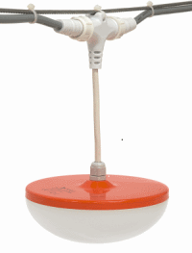

# HWDK-C ECO LED

## Quick Overview

Universal waterproof LED lighting fixture 23W, IP65. 1275mm length , 3000K-light-colour, Perfect and flicker free dimmable from 1 -100% brightness (1-10 VDC) 115-230V, 50/60Hz, Expected lifetime: 43.000hrs.

* Dimmable 0-100%
* maximum energy saving
* ideal for main lighting
* easy installation
* IP65 water light protection

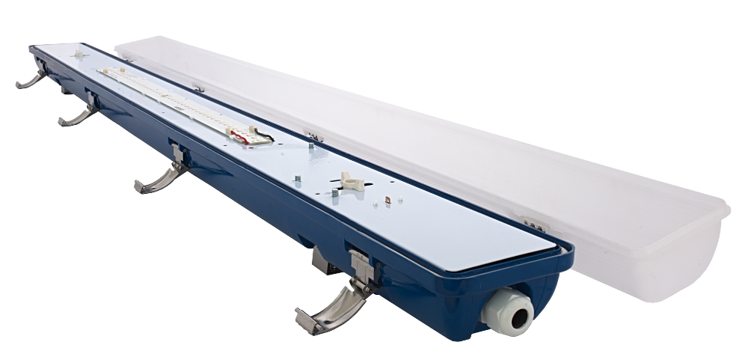

.

# OTUS

## Quick Overview

Dimmable LED energy saving bulb, 2550K. Dimmable from 0 -100% brightness. 220-240 VAC. The perfect alternative to existing CFL, CCFL, Incadescent or incandescent E27 lamps. It gives an even light distribution at high intensities. When using the OTUS in combination with the IUL 27 holder, the OTUS adapter for IUL-27 (art # OAI-27) always has to be used in order to guarantee water-tightness.

* for main lighting
* LED REPLACEMENT (E27)
* 13.5W-1000lumen
* life time 50,000 hour
* dimmable

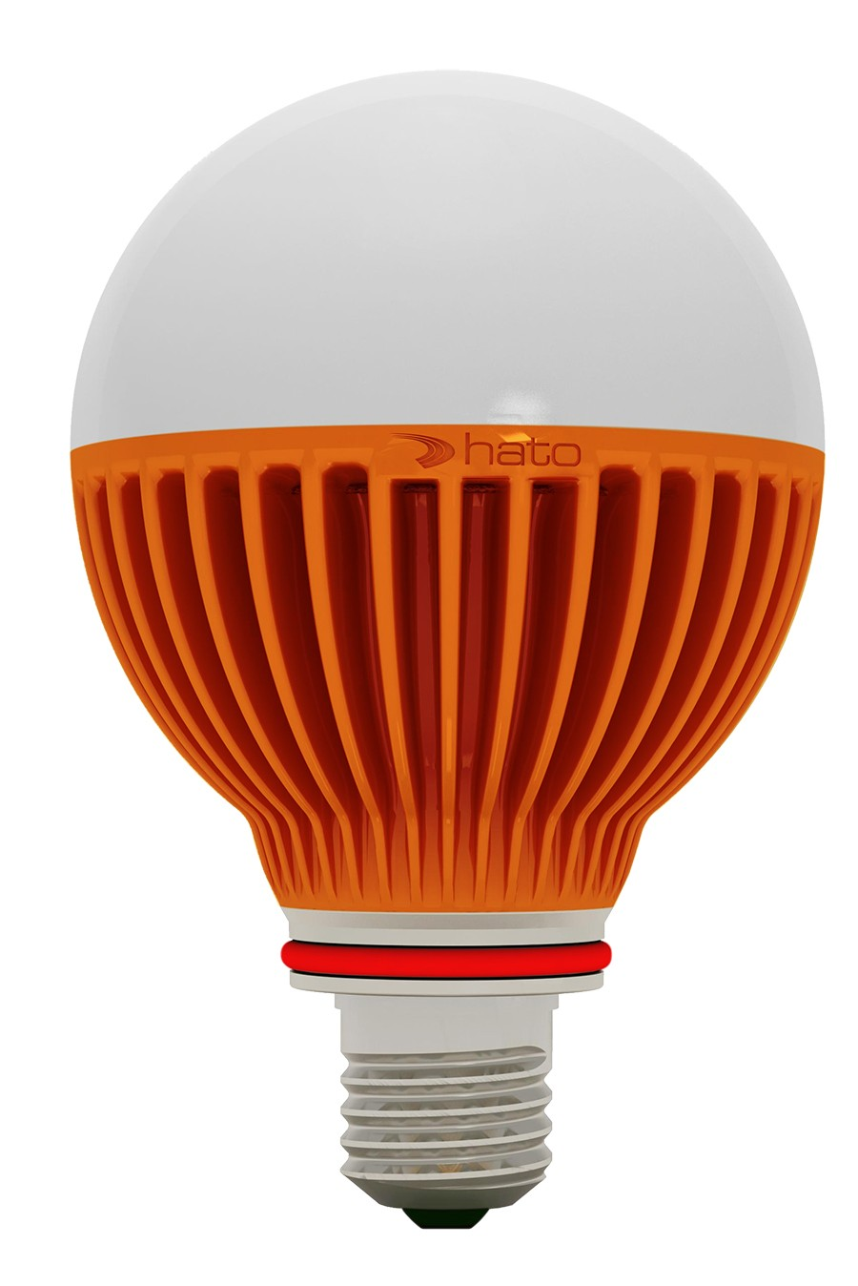

# BUBO LED

## Quick Overview

BUBO LED PMMA 24VDC **3.0 Watt**. Light-colour: Amber (yellow-orange).Diameter 20mm, average lifetime: 30,000 - 60,000 hrs. Protection-class IP67.  
Quick and simple installation with preassembled "Plug & Play" connectors. Max. 36pcs.in serial line installation depending on kind of transformer.

* to be used inside cages
* plastic PMMA resistant to ammonia
* safety voltage 24VDC
* Lifetime 25,000 to 70,000 hours
* various models and colours available

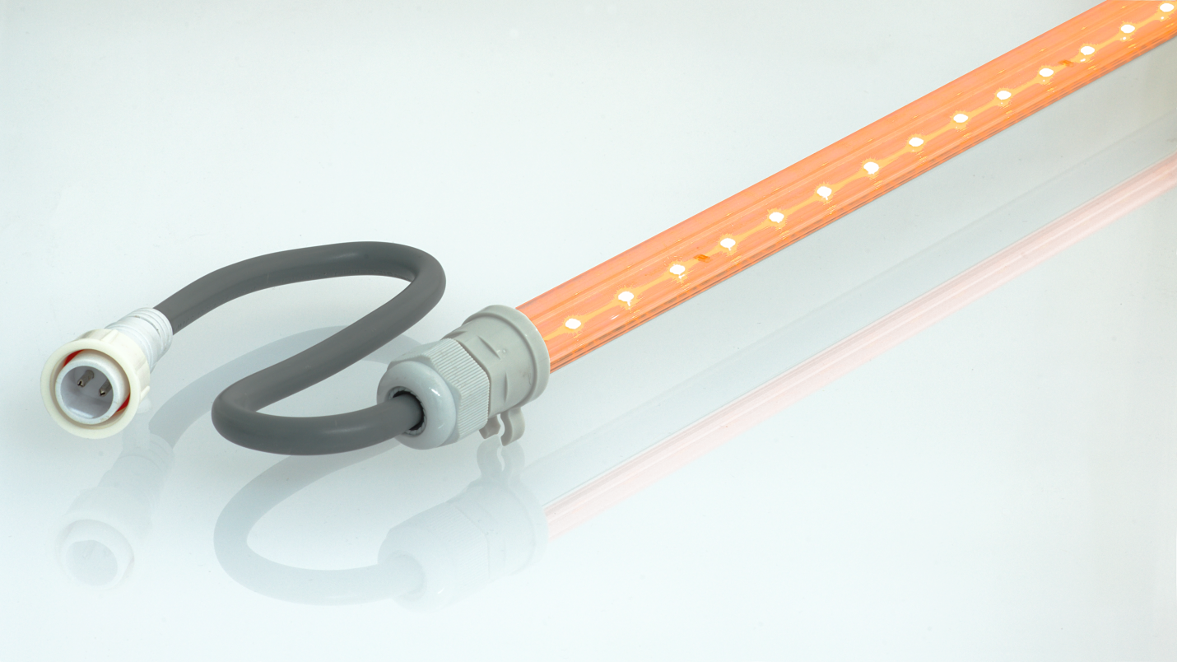

## Quick Overview

Dimmable LED energy saving bulb, 2950K. Dimmable from 0 -100% brightness. 48VDC. The Ninox has been designed for low systems. It gives wide spread light. It can be mounted in closed fixtures.

* Perfectly dimmable 6 W LED bulb
* Specially designed for low system
* safety voltage 48 VDC
* 2950k warm white
* efficiency 63 lm/w (375 lumen)
* Average lifetime 50,000 hour

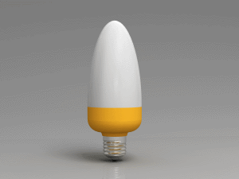

# SURNIA

## Quick Overview

The SURNIA is perfectly designed for low ceiling broiler houses. It has no fluctuation issues and guarantees a perfect light climate. HATO took great care in the look and feel of this light to ensure a maximum animal welfare.

* 48VDC (safe installation)
* 10W – 925 lumen
* 60,000 hour lifetime
* 0 – 100% dimmable
* Flicker free, maximum animal welfare
* [IP67](http://www.hato.lighting/only-the-best/) water and dust resistant

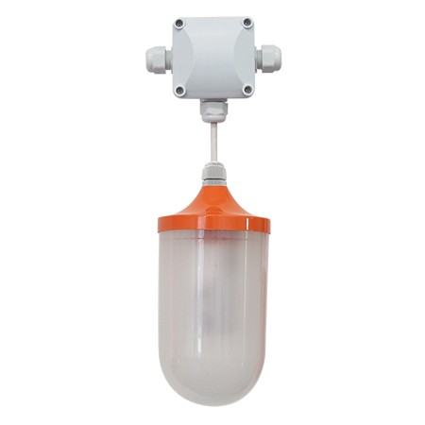

**E-Prefabricated Steel Structure**



**POULEX INTERNATIONAL has been projecting and manufacturing pre fabricated poultry sheds of any size and typology for the last 15 years.**

**Also providing prefabricated steel buildings,**

**rest houses and warehouses .**

**Our poultry houses and livestock sheds grant the highest productive level, by ensuring the best environment to the animals, in any climatic condition.**

**poulex international also means:**

* **a factory with 10,000 m2**
* **skilled personnel**
* **modern equipment and machinary**
* **quality control and product testing**
* **advanced technical skills and international experience.**

**Projects**

**Inside Egypt:**

* **Steel Structure building for komatsu**
* **42 house for cairo poultry in regwa**
* **36 house for montraid poultry**
* **48 house for misr broiler company**
* **36 house for Al wataneya company for broiler**
* **24 house for Al wataneya company for broiler breeder**
* **20 house for Ommat Company .**
* **12 house for Eng.Shokry Guirges in Minya**
* **8 houses for Lara company in Ismailia**
* **4 houses for Al Farouj Al Zahaby in Ismailia**
* **4 houses for Al radwa on Alaamein Road**

**Outside Egypt:**

**Contact us:**

**Main Office:**

**124 El-Haram St,. Giza.Egypt**

**tel: +2 39754997**

**Fax: +2 39754993**

**Email: info@poulex-group.com**

**Factory:**

**kilo 26th Industrial zone - Abu Rawash .6th of october**

**tel:+2 35392496**

**fax: +2 35392494**

**Email: info@poulex-group.com**

**HOME PAGE**

**WHAT WE DO ?**

**supply of turn-key projects for poultry and livestock , providing the latest technologies and concepts .**

**1- 24/7 customer service**

**2- life time guaranteed products**

**3-prefabricated steel structure**

**providing with the latest machinary and skilled manpower with quality control and product testing.**

**4-all in one**

**not just equipment and the steel but also all the accessories needed are available**

**matensash el poulex group logo wel bar el abyad el fo2**

**fa gher deef hato fel partners**

**elslide show 3 sowar**

**el kalam el fel slider**

**we are poulex group**

**solutions and innovations**

**Complete turn key projects**

**prefabricated steel structure**